SIMULATION BASED ASSIGNMENT ASSESSMENT RUBRIC
BACHELOR OF TECHNOLOGY
IN
COMPUTER SCIENCE AND ENGINEERING
By

NAME OF THE STUDENT: VIVEK RAJPUROHIT
Mail ID: vivekrajpurohit28@gmail.com
Registration number: 11800965
Roll No: K18APA05
Section: K18AP
GITHUB LINK:
https://github.com/vivekrajpurohit/OS-PROJECT-



School of Computer Science and Engineering
Lovely Professional University
Phagwara, Punjab (India)

* Problem Statement: -
* Sudesh Sharma is a Linux expert who wants to have an online system where he can
* handle student queries. Since there can be multiple requests at any time, he wishes
* to dedicate a fixed amount of time to every request so that everyone gets a fair
* share of his time. He will log into the System from 10am to 12am only. He wants to
* have separate requests queues for students and faculty. Implement a strategy for the
* same. The summary at the end of the session should include the total time he spent on
* handling queries and average query time.

DESCRIPTION:
- Explain the problems in terms of operating system concept?
The problem assigned is asking for using 2 queues to assign time to students as well as faculties in some order. And the time share should be fixed as mentioned in the problem. So, I will be applying Round Robin Algorithm in this scenario because we are dealing with fixed time quantum. But there is another catch we have two queues (one of faculties and other of students) so I decided to assign more priority to teacher’s queries and now if at certain point of time we have to decide between resolving teacher’s queries and student queries, we will proceed by resolving teacher’s query first.

ALGORITHM:
- Write algorithm for proposed solution of assigned problem.
The algorithm proposed above is as follows:
- Sort the faculties and students by their arrival time.
- Start with the minimum arrival time (10:00 AM) and push all the faculties and students in their respective queue.
- While all the faculties are not processed in the queue 1. Process them.
- While processing every query add all the new students and faculty arriving at updated time.
- Then process the student queue in same order.
- While processing the student or faculty queue if remaining burst time is greater than time quanta just subtract time quanta from the burst time and push it again to the back of the queue otherwise the process is completed, and we have completion time.
- Now the Wait time = Completion – Arrival – Burst
- And Turnaround Time = Completion - Arrival
- Calculate Total time spent on handling queries and average query time and print the same.

PURPOSE OF USE:
- Calculate complexity of implemented algorithm. (Student must specify complexity of each line of code along with overall complexity)
Since the program is quite large, I am going to specify complexity of the function which is processing the input in modified Round Robin Algorithm. Here are the steps: -
- Sort the array of faculties and students by their arrival time. Though we expect the input in sorted order in real life scenario because the arrival time will only increase with time (monotonic) but in order to make the program robust we are still sorting it with a comparator which is sorting it according to arrival time. ---- O(Flog(F) + S(log(S))
Here F – No of Faculties
S – No of Students
- Start from minimum arrival time (10:00 AM) and push all the faculties and students with current arrival time to queue 1 and queue 2. O (F + S)
- Give the processes a certain time quantum and increase arrival time and again try to add all faculties and students with current arrival time to queue 1 and queue 2 respectively.
- The above two steps are just Round Robin algorithm in two queues with priority given to the queue 1 (faculty queue) -- O (F + S).
- So, the overall time complexity is O(Flog(F) + S(log(S)) and the log factor is introduced in order to make the program robust.

CODE SNIPPET:
- Explain all constraints given in the problem. Attach the code snippet of the implemented constraint.
There is only one constraint given in the problem that is the admin use his system from 10AM to 12PM (14 hrs.) and I managed to validate the arrival time of the given input by sending it through a function which validated two things: -
- Arrival time is a valid time as asked.
- It falls in the range of 10:00 to 23:59
The code snippet of implemented validator is given below: -
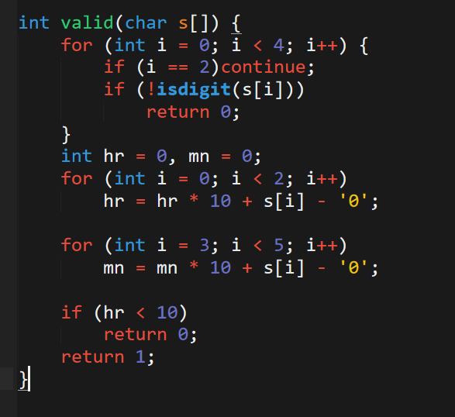

- If you have implemented any additional algorithm to support the solution, explain need and usage of the same.
The algorithm implemented needed to support two queues because we must maintain two different queues for faculties and students. So, I added priority to the faculty queue and now we have two queues, but we know which one to process first in case of collision.
Apart from that I used sorting as an additional measure to sort the inputs according to arrival time.

Boundary condition of implemented code:
- Explain the boundary conditions of the implemented code
The boundary conditions tested for this problem are as follows: -
- Using the arrival time as 10:00 [24 hr. format]
- The arrival time can vary up to 23:59 (maximum bounds)
- The burst time can vary and should be given in seconds There are no bounds in burst time. It should fit in integer [0 to 10⁹]
- There can be several test cases. [1 to 10⁵]

Test case:
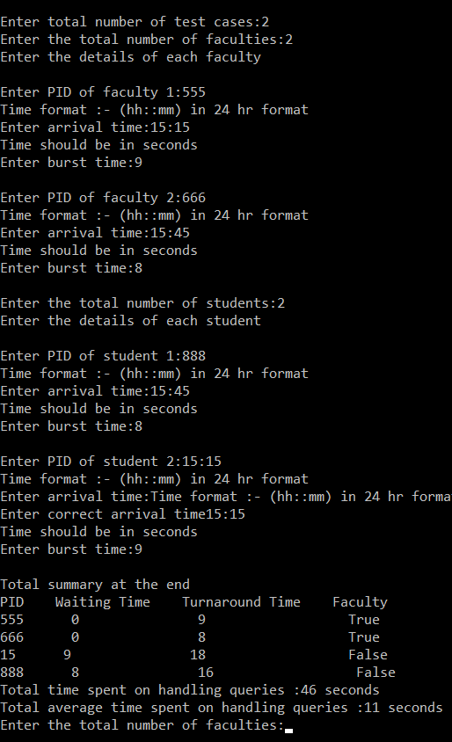

CODE SNIPPET:
/*
* Problem Statement: -
* Sudesh Sharma is a Linux expert who wants to have an online system where he can
* handle student queries. Since there can be multiple requests at any time, he wishes
* to dedicate a fixed amount of time to every request so that everyone gets a fair
* share of his time. He will log into the System from 10am to 12am only. He wants to
* have separate requests queues for students and faculty. Implement a strategy for the
* same. The summary at the end of the session should include the total time he spent on
* handling queries and average query time.
*
* NAME OF STUDENT
* VIVEK RAJPUROHIT (11800965)
*
* Solution Implemented to Solve Problem: -
* Since we are planning to have different queues for students and faculties and each
* of them needs a fixed time quantum and in order to maximize the efficiency I will be
* calculating optimal time quantum to get the maximum efficiency in the shortest period
* of time.
*/

#include <stdio.h>
#include <limits.h>
#include <stdlib.h>
#include <windef.h>

//maxn means the maximum no of students and faculties we can have
#define maxn 100010

int time_quanta = 2, cur = 0;
typedef struct {
char arrival_time[50];
int pid, at, burst_time, priority, wt, id, td;
} data;
data faculty[maxn], student[maxn], q1[maxn], q2[maxn];

void calculate_time_in_seconds(data *d) {
d->at = 0;
int ghnta = 0, minutes = 0;
for (int ide = 0; ide < 2; ide++)
ghnta = ghnta * 10 + d->arrival_time[ide] - '0';

for (int ide = 3; ide < 5; ide++)
minutes = minutes * 10 + d->arrival_time[ide] - '0';

d->at = ghnta * 60 + minutes;
}

int valid(char s[]) {
for (int ide = 0; ide < 4; ide++) {
if (ide == 2)continue;
if (!isdigit(s[ide]))
return 0;
}
int ghnta = 0, minutes = 0;
for (int ide = 0; ide < 2; ide++)
ghnta = ghnta * 10 + s[ide] - '0';

for (int ide = 3; ide < 5; ide++)
minutes = minutes * 10 + s[ide] - '0';

if (ghnta < 10)
return 0;
return 1;
}

int comp(const void *appr, const void *bbbr) {
data *A = (data *) appr;
data *B = (data *) bbbr;
if (A->at == B->at)
return A->id - B->id;
return A->at - B->at;
}

void solve_queries(int f, int s) {
// Since we are not given whom to prioritize we will consider
// prioritizing faculty first that means if we have anything in left
// faculty in queue we process it first and then we
// go to the children queue

qsort((void *) faculty, f, sizeof(faculty[0]), comp);
qsort((void *) student, s, sizeof(student[0]), comp);

for (int ide = 0; ide < f; ide++)
faculty[ide].id = ide;
for (int ide = 0; ide < s; ide++)
student[ide].id = ide;

int min_arrival_time = 10 * 60;//10:00AM
cur = min_arrival_time;
int id1 = 0, id2 = 0, st1 = 0, st2 = 0;

int x1 = 0, y1, x2 = 0, y2;
while (id1 < f || id2 < s) {
if (id1 < f)
while (id1 < f && faculty[id1].at <= cur)
q1[st1++] = faculty[id1++];

if (id2 < s)
while (id2 < s && student[id2].at <= cur)
q2[st2++] = student[id2++];

y1 = st1 - 1;
y2 = st2 - 1;

point1:
while (x1 <= y1) {
int delta = min(q1[x1].burst_time, time_quanta);
q1[x1].burst_time -= delta;
cur += delta;
if (q1[x1].burst_time)
q1[st1++] = q1[x1];
else {
int tp = q1[x1].id;
faculty[tp].wt = cur - faculty[tp].at - faculty[tp].burst_time;
faculty[tp].td = cur - faculty[tp].at;
}

if (id1 < f)
while (id1 < f && faculty[id1].at <= cur)
q1[st1++] = faculty[id1++];

if (id2 < s)
while (id2 < s && student[id2].at <= cur)
q2[st2++] = student[id2++];
y2 = st2 - 1;
y1 = st1 - 1;
x1++;
}

while (x2 <= y2) {
int delta = min(q2[x2].burst_time, time_quanta);
q2[x2].burst_time -= delta;
cur += delta;

if (q2[x2].burst_time)
q2[st2++] = q2[x2];
else {
int tp = q2[x2].id;
student[tp].wt = cur - student[tp].at - student[tp].burst_time;
student[tp].td = cur - student[tp].at;
}

if (id1 < f)
while (id1 < f && faculty[id1].at <= cur && faculty[id1].burst_time != 0)
q1[st1++] = faculty[id1++];

if (id2 < s)
while (id2 < s && student[id2].at <= cur && student[id1].burst_time != 0)
q2[st2++] = student[id2++];
y2 = st2 - 1;
y1 = st1 - 1;
x2++;
if (x1 <= y1)goto point1;
}

if (x1 <= y1 || x2 <= y2)
continue;
if (id1 < f && id2 < s)
cur = min(faculty[id1].at, student[id2].at);
else if (id1 < f)
cur = faculty[id1].at;
else if (id2 < s)
cur = student[id2].at;
else break;
}
}

void solve() {
int no_of_faculty, no_of_students;

printf("WHAT IS NUMBER OF FACULTY:");
scanf("%d", &no_of_faculty);

printf("ENTER THE DETAILS OF FACULTY \n");
printf("\n");
for (int id = 0; id < no_of_faculty; id++) {
//PID
printf("WHAT IS PID OF FACULTY %d:", id + 1);
scanf("%d", &faculty[id].pid);

// Entering the arrival time
printf("Time format :- (hh:mm) in 24 hr format\n");
printf("WHAT IS ARRIVAL TIME:");
scanf("%s", faculty[id].arrival_time);

while (!valid(faculty[id].arrival_time)) {
printf("Time format :- (hh:mm) in 24 hr format\n");
printf("Enter correct arrival time");
scanf("%s", faculty[id].arrival_time);
}

printf("Time should be in seconds\n");
printf("Enter burst time:");
scanf("%d", &faculty[id].burst_time);

faculty[id].priority = 0;
calculate_time_in_seconds(&faculty[id]);
faculty[id].id = id;
printf("\n");
}

printf("WHAT ARE TOTAL NUMBERS OD STUDENTS:");
scanf("%d", &no_of_students);

printf("Enter the details of each student\n");
printf("\n");
for (int id = 0; id < no_of_students; id++) {
//PID
printf("Enter PID of student %d:", id + 1);
scanf("%d", &student[id].pid);

//Entering the arrival time
printf("Time format :- (hh::mm) in 24 hr format\n");
printf("Enter arrival time:");
scanf("%s", student[id].arrival_time);

while (!valid(student[id].arrival_time)) {
printf("Time format :- (hh::mm) in 24 hr format\n");
printf("Enter correct arrival time");
scanf("%s", student[id].arrival_time);
}

//Burst time
printf("Time should be in seconds\n");
printf("Enter burst time:");
scanf("%d", &student[id].burst_time);

student[id].priority = 1;
calculate_time_in_seconds(&student[id]);
faculty[id].id = id;

printf("\n");
}
solve_queries(no_of_faculty, no_of_students);

printf("Total summary at the end\n");
int tp = -1;
if (no_of_faculty)
tp = faculty[0].at;
if (no_of_students) {
if (tp != -1) {
tp = min(tp, student[0].at);
} else {
tp = student[0].at;
}
}
if (tp == -1)
tp = 0;

printf("PID WAITING TIME TURNAROUND TIME FACULTY\n");
for (int i = 0; i < no_of_faculty; i++) {
printf("%d %d %d True\n", faculty[i].pid, faculty[i].wt, faculty[i].td);
}
for (int i = 0; i < no_of_students; i++) {
printf("%d %d %d False\n", student[i].pid, student[i].wt, student[i].td);
}
printf("Total time spent on handling queries :%d seconds\n", cur - tp);
printf("Total average time spent on handling queries :%d seconds\n", (cur - tp) / (no_of_faculty + no_of_students));
}

//Write the input format in here to show the user how the input is handled
void input_format() {
printf("Program to calculate Waiting time and Turn around time\n");
printf("\n\n");
}

int main() {
int test_case;
input_format();
printf("Enter total number of test cases:");
scanf("%d", &test_case);

while (test_case--)
solve();

return 0;
}

GITHUB LINK:
https://github.com/vivekrajpurohit/OS-PROJECT-

